2015 OVPES Annual Meeting

Teaching as Labor, Learning as Work:

Educational Ideals and the Factory of Knowledge

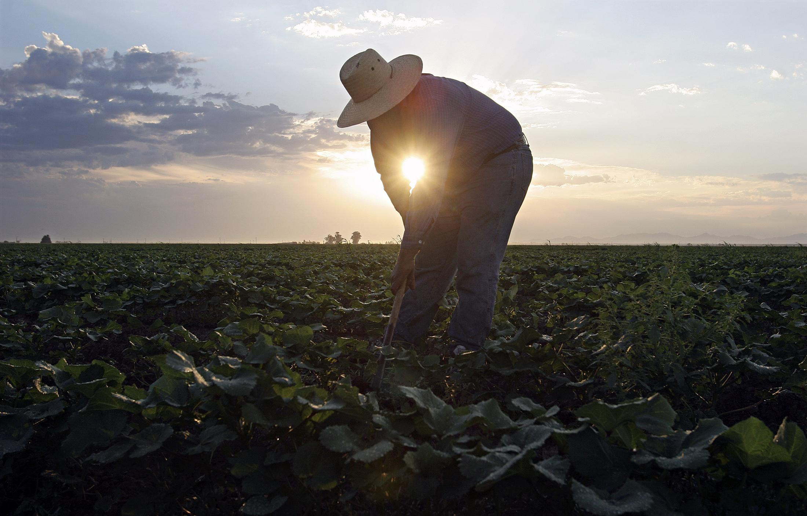
Copyright (2015) Thomson Reuters

Bergamo Center | Dayton, Ohio | September 11-13, 2015

Friday, September 11
_____________________________________________________________________________________

7:00 – 10:00 pm: Opening Reception (Barrett)
____________________________________________________________________________________

Saturday, September 12
_____________________________________________________________________________________

7:00 – 7:30 am: Yoga Stretch (Darby)

7:30 – 8:30 am: Breakfast (Dining Room)
_____________________________________________________________________________________

8:30-9:45 am: Concurrent Sessions

1A Philosophical Contributions to Mindful Teaching (Chaminade)

The Imperative of Trust: Trust In Students as a Foundational Teacher Value
Jonathan Taft Sallée (Lewis University)

Disclosure and Credibility in the Classroom
Thomas Priestley (Vanderbilt University, Peabody College)

Presence and Soul in the Action of Educating
Timothy Leonard (Independent Scholar)

Moderator: Andrea Hyde (Western Illinois University)

1B Media, Creativity and Civic Education (Barrett)

Philosophy of Teaching Creatively in The Water is Wide: Reawakening Childhood Genius
Judi Thorn (Oklahoma State University)

Assessing Critical Media Literacy
Jamie E. Teeple (Ohio State University)

Winnicott’s Object Relations Theory Meets Deweyan Aesthetics: Toward a Philosophy of
School Librarianship
Virginia Worley (Oklahoma State University)

Moderator: Douglas Yacek (Ohio State University)

1C Panel: Education and Hope: Affective Liquidity for Very Late Capitalism? (Darby)

Chris Higgins (University of Illinois, Urbana-Champaign)
Katherine Jo (University of Illinois, Urbana-Champaign)
Kip Kline (Lewis University)

Moderator: Chris Higgins (University of Illinois, Urbana-Champaign)

1D Framing Past and Future (Bordeaux)

Imaging the End of Everything: Popular Media Culture Scripts the Ecological End Game and the Coming Work of Mourning
Stacy Otto (Illinois State University)

The Need for Roots Redux: On the Supposed Disciplinary Right to A Nonideal Theory
Gabriel Keehn (Georgia State University)

The Work of the Prophetic Teacher in Democratizing Education
Jeffrey Dunn (Ohio State University)

Moderator: Stacy Otto (Illinois State University)
___________________________________________________________________________________

9:45-10:00 am: Break
_____________________________________________________________________________________

10:00 – 11:15 am: Concurrent Sessions

2A Working under/within/through Neoliberal School Reform (Chaminade)

Dropout Factories: The Profitability of "At-Risk" Students
Nicholas Eastman (Georgia State University)

Accountability and Poetry: A Philosophical Account of Standardized Testing and the Conception of Learning as "Work"
Brett Bertucio (University of Wisconsin-Madison)

Moderator: Shaka Rawls (University of Illinois, Chicago)

2B Corrupting Practices (Barrett)

Sex, Labor, and Schools: Sex Education and the Need for Alternative Sexual Pedagogies
Caitlin Howlett (Indiana University)

Should We Use Directive Methods for Teaching Controversial Issues?
Douglas Yacek (Ohio State University)

What is Wrong, Really, with Paying Students Cash for Academic Work?
Bryan Warnick (Ohio State University)

Moderator: Mark Jonas (Wheaton College)

2C Panel: Author Meets Critics: Craig Cunningham's Systems Theory for Pragmatic Schooling (Darby)

Craig Cunningham (National Louis University)
Jane Blanken-Webb (University of Illinois, Urbana-Champaign)
Deron Boyles (Georgia State University)
Richard Quantz (Miami University)

Chair & Moderator: Amy Shuffelton (Loyola University, Chicago)
2D Theorizing the Devaluing of Black Lives (Bordeaux)

"High Expectations" Discourse as an Epistemology of Oppression: Implications for Urban Education
Morgan D. Anderson (Georgia State University)

Interpellating dispossession: Distributions of vulnerability and the precarious mattering of lives
Lisa M. Perhamus (Grand Valley State University)
Clarence W. Joldersma (Calvin College)

Classroom Caring as Labor: Casuistry, the Care Gap and Phronesis
Sheron Fraser-Burgess (Ball State University)

Moderator: Kip Kline (Lewis University)
_____________________________________________________________________________________

11:15 – 11:30 am: Break
_____________________________________________________________________________________

11:30 – 12:45 am: Phil Smith Symposium (Bordeaux)

Introduction: Greg Loving (University of Cincinnati-Clermont College)

Phil Smith Lecture: The Transformation of Higher Education and Its Impact on Inequality and Poverty
Rudy Fichtenbaum (Wright State University)
_____________________________________________________________________________________

12:45-1:45 pm: Lunch (Dining Room)
_____________________________________________________________________________________

2:00 – 3:15 pm: Concurrent Sessions

3A Parental Involvement (Chaminade)

Parental Labor and Public Schools: Now You See It, Now You Don’t
Amy Shuffelton (Loyola University, Chicago)

The Ethics of Conferring Parental Advantage: A Question of Parental Liberty versus Societal Equality
J. Kessa Roberts (Ohio State University)

Organic Oppressors
Carl Templin (University of Toledo)

Moderator: Stacy Otto (Illinois State University)

3B Freedom and Democratic Education (Barrett)
The Politics of Recitation
David I. Backer (Cleveland State University)

Education of the Polis, by the Polis: A Platonic Take on Democratic Education
Samantha Deane (Loyola University, Chicago)

A Labor of Love: Education as the practice of freedom
Katrina Dillon (University of New Mexico)

Moderator: Deron Boyles (Georgia State University)

3C Aesthetics in Service of Democratic Education (Bordeaux)

A Deweyan Analysis of *Alice's Adventures in Wonderland: * Education as Aesthetic Experience
Matthew Pascucci (Oklahoma State University)

Broadening Multicultural Education from Existential Aesthetics
Shaobing Li (Miami University)

The Pedagogical Power of Myth: Cultivating the Human in a Bureaucratic World
Thomas Falk (University of Dayton)

Moderator: Brad Rowe (Monmouth College)

3D Theoretical Critiques of Educational Research (Darby)

Revisiting ‘What Works’ in Education: Labors of Care within the Special Education Archive
Benjamin Kelsey Kearl (Indiana University)

The Ethics of Critical Inquiry: Parrhesia as a Framework for Critical Inquiry for Qualitative Educational Research
David Roof (Ball State University)
Elena Polush (Ball State University)
Phil Boltz (Ball State University)

A Lack of Justification for Being Entitled and Knowledge: A Response to Caduri
Justin Christopher (University of Iowa)

Moderator: Mike Gunzenhauser (University of Pittsburgh)
_____________________________________________________________________________________

3:15 – 3:30 pm: Break
_____________________________________________________________________________________

3:30 – 4:45 pm: Concurrent Sessions

4A Education and Work in Late Capitalism (Chaminade)

The U.S. Working-Class Intellectual: Education, 21st Century Grass-Roots Organizing, and The Development Of a (Re)New(Ed) School of Thought
James Aucoin (Georgia State University)

The Corporate Assault on Schools: Ethics, Academic Freedom, and Critical Policy Studies
Deron Boyles (Georgia State University)

The Problem of Training In Industrial Affect for a Post-Industrial World
Dan Reyes (Antioch University)

Moderator: Kevin Gary (Valparaiso University)

4B Panel: Education as a Tragic Labor of Love (Barrett)
Brad Rowe (Monmouth College)
Jessica Heybach & André Meeks (Aurora University)
Eric Sheffield (Missouri State University)
Leanne Sunderman (Tolles Career and Technical Center)

Moderator: Thomas Falk (Ohio State University)

4C Ethics in Teaching and Society (Bordeaux)

Learning to Rest
Katherine Jo (University of Illinois, Urbana-Champaign)

Dissolving the Paradox of Moral Education
Yoshiaki Nakazawa (Valparaiso University)

Democracy and Social Ethics Reconsidered
Bertram C. Bruce (University of Illinois, Urbana-Champaign)

Moderator: Andrea Hyde (Western Illinois University)

_____________________________________________________________________________________

4:45 – 5:00 pm: Break
_____________________________________________________________________________________

5:00 – 6:15 pm: Presidential Address (Bordeaux)

From Elitism to Populism: A Foucauldian Tragedy of Jell-O, Cell Phones and Higher Education
Greg Loving (University of Cincinnati-Claremont College)

Respondent: Sheron Fraser-Burgess (Ball State University)

_____________________________________________________________________________________

6:30 – 7:30 pm: Dinner (Dining Room)
This year, guests have the option to dine on site (pre-registration/additional fee).

Carpools for dining out meet in the lobby at 6:25.
_____________________________________________________________________________________

8:30 – 10:30 pm: Social (Dining Room)

Drinks, Dessert, and Lively Conversation
_____________________________________________________________________________________

Sunday, September 13
_____________________________________________________________________________________

8:00 – 9:00 am: Breakfast (Dining Room)
_____________________________________________________________________________________

9:00 – 10:15 am: Concurrent Sessions

5A Panel: Baudrillard, Black Mirror, and the Limits of Critical Media Literacy (Bordeaux)
Kip Kline (Lewis University)
Michael Bulfin (Lewis University)
Kevin Beirne (Lewis University)

Discussant & Moderator: Jessica Heybach (Aurora University)

5B Panel: Education for Meaningful Work (Chaminade)

Kevin Gary (Valparaiso University)
Mark Jonas(Wheaton College)
Alven Neiman (Independent Scholar)

Moderator: Kevin Gary (Valparaiso University)

5C New Questions on Equality (Barrett)

Employing Teachers for Social Justice: A Critique of Labor Practices within the Education Reform Movement
Sarah Stitzlein (University of Cincinnati)
Barrett Smith (University of Cincinnati)

Equality of What in Democratic Education? A Senian Alternative to Gutmann’s Democratic Interpretation of Educational Equality
Tony DeCesare (St. Louis University)

A Philosophical Analysis of Western Feminism and Islamic Feminism: A Scholarly “Tug of War.”
Tasneem Amatullah (Miami University)

Moderator: Eric Sheffield (Missouri State University)
_____________________________________________________________________________________

10:15 – 10:45 am: Break and Room Check-Out

______________________________________________________________________________________

10:45 – 12:00 pm: Plenary Session

Work and Labor in Democracy and Education The John Dewey Society (Bordeaux)

The Centrality of Habits in Dewey’s Democracy and Education
Lance Mason (Indiana University-Kokomo)

Negative and Positive Freedom in Education: Berlin and Dewey on Freedom in Teacher and Student Work
Dan Mamlok (Miami University)

Dewey on Educating Vocation: Bringing Adult Learning to the University
Mark Keitges (University of Illinois, Urbana-Champaign)

Chair & Moderator: Sarah Stitzlein (University of Cincinnati)

_____________________________________________________________________________________

12:15 – 1:30 pm: Business Meeting (Bordeaux)

_____________________________________________________________________________________

1:30 pm: Annual Meeting Adjourned

Safe Travels!
Current Officers:
- President Greg Loving, University of Cincinnati, Clermont College
- President Elect Stacy Otto, Illinois State University
- Immediate Past President Bryan Warnick, Ohio State University
- Secretary-Treasurer Jessica Heybach, Aurora University

Executive Committee
- Mark Jonas, Wheaton College [’18]
- Jennifer Logue, Southern Illinois University-Edwardsville [’18]
- Eric Sheffield, Missouri State University [’17]

2015 Conference
- Program Chair Andrea Hyde, Western Illinois University
- Site Coordinator Adrienne Pickett, University of Illinois, Champaign-Urbana

2015 Program Committee

- Angela Hurley, Transylvania University
- Brad Rowe, Monmouth College
- Eric Sheffield, Missouri State University
- Jim LaPrad, Western Illinois University
- Seth Knappen, Black Hawk College
- Amy Shuffelton, Loyola University
- Julie Nagashima, University of Pittsburgh
- Douglas Yacek, Ohio State University
- Shaka Rawls, University of Illinois-Chicago

